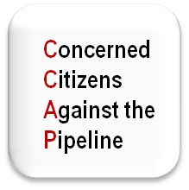**Durham Township**

**Concerned Citizens Meeting**

**Topic: PennEast Pipeline**-All issues/concerns/ideas/development/infrastructure/future affects

Pipeline on your neighbor’s property?

Pipeline on your property?

**Date: Monday November 10, 2014**

**Place:** Durham Township Building

~ 215 Old Furnace Road Durham, Pa 18039

**Time:** 7pm

**Contact:** Tina Venini C: 610-737-1290

Concerned Citizens Meeting for Concerned Citizens against the Pipeline